Database Project on

ONLINE SHIPMENT DATABASE MANAGEMENT SYSTEM

SUBMITTED BY

Name: SURAJ S JARALI  SUDARSHAN | USN: 1MS16CS106  1MS16CS105
VARUN B N | 1MS116CS112

Database System Laboratory
CSL58

DEPARTMENT OF COMPUTER SCIENCE & ENGINEERING
RAMAIAH INSTITUTE OF TECHNOLOGY
(Autonomous Institute, Affiliated to VTU)
AUGUST-DECEMBER 2018
BANGALORE-560054

Abstract

Consider a company which is basically an Online Retail Company which accepts orders online only. Hence there will be different orders of different products which are being ordered by the users. These orders may further have to be delivered to multiple addresses by different Logistics(say e-kart etc).Our project aims at how these orders are being coordinated with the logistics and also find the status of these products i.e. whether they are delivered or not. Using the details of these orders we further calculate the revenues such as how many orders have been ordered, the total price through cash or online etc. We further show how these orders are sorted according the convenience of the logistics. This would help when there is a large amount of data to be sorted in a large scale.

ER Diagram of the Topic

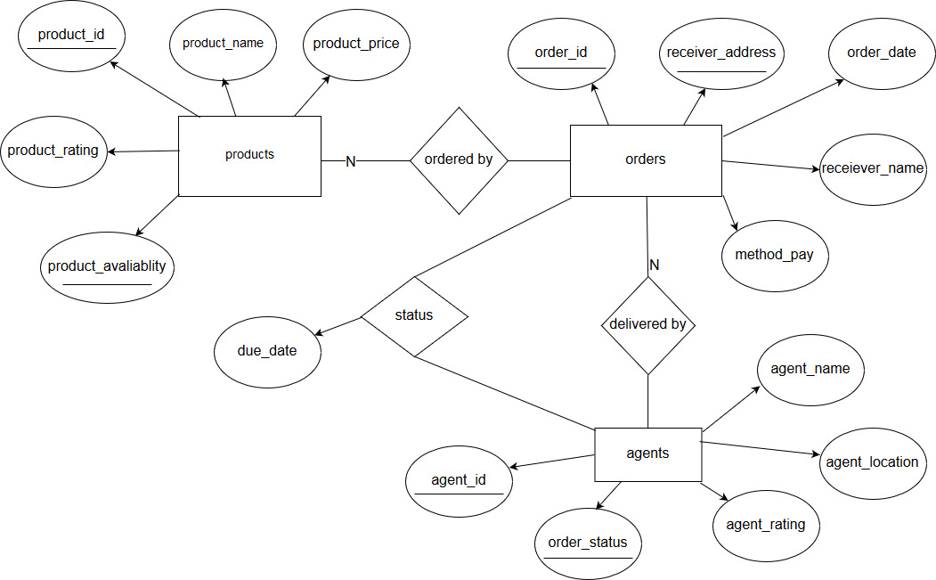

Schema of the Topic

